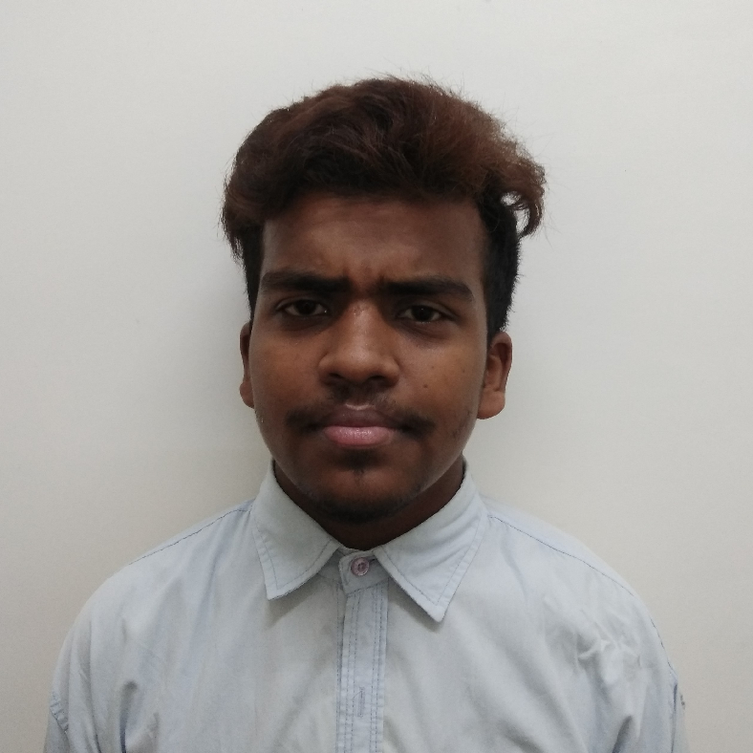
Nalinashay Keshrwani
B.E - Electronics Engineering
DOB - 01/04/1998
Email Id - Nalinashay@gmail.com
Cell no: - +91-8602816966
LinkedIn - https://www.linkedin.com/in/nalinashay-keshrwani-b17203165

Career Objectives:
To do a job of professional standards and ethics, have a responsible position in an organization that can probe the qualification and experience I have, passion to work as a strong team player and to help the organization’s development and growth.

Academic Credentials:

Examination | Year | Percentage | Institution | Board/University
B.E. (Electronics) | 2019 | 6.02 | Madhav Institute of Technology & Science, Gwalior, M.P. | RGPV University Bhopal
Class XII | 2015 | 85.3% | Govt.Excellance school damoh M.P. | MP Board Bhopal
Class X | 2013 | 78.4% | Govt.Excellance school damoh, M.P. | MP Board Bhopal

Projects & Trainings:
- Project - “Rhythm Follower Flashing Light. (using mic)
- Major Project - “Gas Security Device” using Arduino and Gas Sensor (July ‘13 – April ‘14)
- Summer Training - Minor Training in Indian railways where I learn about the control system of Indian railways IRCTC GPS system.
- Major training on “EMOTECH” on internet of things.
- Attended two days’ workshop of Quadcopter in IIT Delhi, and knowledge about Quadcopter.
- Attended workshop of Internet of things in IIT Kanpur.
- Attended classes of personality development program in T.I.M.E Institute.

Technical Skills:
Operating System - Windows.
Programming Language - JAVA, HTML, CSS
Frameworks - Hibernate, Strut, Spring.
Web-based Enterprise application’s - Web-Services.
IDE’s Tools - Eclipse, MyEclipse, NetBeans.
Favorite Subjects - Analog & Digital Communication, Area Of
Interest Software & Communication.

Rewards & Recognitions:

- Achieved Certificate of NCC-A exam conducted by NCC Unit Sagar MP.
- Achieved state level certificate in Paschim Bharat Science Exhibition Jabalpur MP.
- Achieved certificates in different Science Exhibition they are zonal level, district level etc.

Co-Curricular:
- work as a Coordinator in Organizing Committee The institution of Engineering and Technology (IET).
- Experience of IET Tech Fest.
- Organizing Committee which shoes my managerial, strong communication and interpersonal skills.
- Make many models for betterment of our society.

Languages
• English - Fluent
• Hindi - Fluent

Interests & Hobbies:
- Cooking,
- Writing,

I hereby declare that the information mentioned above is correct for the best of my knowledge and belief.
Date:
Place: DELHI (NCR) NALINASHAY KESHRWANI

